**Kit - Arduino - Potentiometer Lab**

**CODE:**

int sensorPin = A0; // select the input pin for the potentiometer

int ledPin = 13; // select the pin for the LED

int sensorValue = 0; // variable to store the value coming from the sensor

void setup() {

  // declare the ledPin as an OUTPUT:

  pinMode(ledPin, OUTPUT);

  Serial.begin(9600);

}

void loop() {

  // read the value from the sensor:

  sensorValue = analogRead(sensorPin);

  Serial.println(sensorValue);

  // turn the ledPin on

  digitalWrite(ledPin, HIGH);

  // stop the program for <sensorValue> milliseconds:

  delay(sensorValue);

  // turn the ledPin off:

  digitalWrite(ledPin, LOW);

  // stop the program for for <sensorValue> milliseconds:

  delay(sensorValue);

}

**[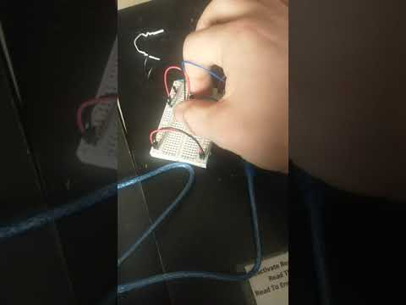](https://www.youtube.com/embed/UzGfd9E7M4w?feature=oembed)**

**Lab Description:**

This lab turned out to be fairly simple. I hooked up the power and ground rail on one side of the breadboard to the 5v and ground pins and then jumped that to the other side of the breadboard to distribute power. I placed the potentiometer onto the breadboard with one pin on one side of the breadboard and the other two on the other side. I attached the single potentiometer pin to A0 (analog input), and made sure the other two pins were supplied power and ground form the rail. Finally, I placed the LED, ran a wire from its cathode leg to digital output pin 13, grounded its anode leg, and placed a resistor in series with the LED to limit the amount of current flowing through it.

The code supplied worked perfectly the first time and I ran into no issues.